**Lab Practical #01:**

Study of basic networking commands and IP configuration.

**Practical Assignment #01:**

1. Perform and explain various networking commands listed below:

1. ipconfig
2. ping
3. getmac iv. systeminfo
4. traceroute / tracert
5. netstat
6. nslookup
7. hostname
8. pathping x. arp

# 1. ipconfig

**Description:**

|  |  |  |  |  |
| --- | --- | --- | --- | --- |
| **No.** |  |  | **Option** | **Description** |
| **1** | Ipconfig |  |  | displays your computer's current network configuration, including IP address, subnet mask, default gateway, and DNS servers |
| **2** | release |  |  | command sends a DHCPRELEASE message to your DHCP server, instructing it to immediately give up your computer's current IP address and configuration. |
| **3** | renew |  |  | Renews DHCP configuration for all adapters (if an adapter is not specified) or for a specific adapter if the *adapter* parameter is included. This parameter is available only on computers with adapters that are configured to obtain an IP address automatically. To specify an adapter name, type the adapter name that appears when you use **ipconfig** without parameters. |
| **4** | all |  |  | Displays the full TCP/IP configuration for all adapters. Adapters can represent physical interfaces, such as installed network adapters, or logical interfaces, such as dial-up connections. |
| **5** | setclassid |  |  | Configures the DHCP class ID for a specified adapter. To set the DHCP class ID for all adapters, use the asterisk (**\***) wildcard character in place of *adapter*. This parameter is available only on computers with adapters that are configured to obtain an IP address automatically. |

**Implementation:**

## 1)

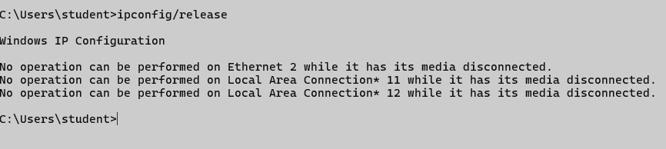

## 2)

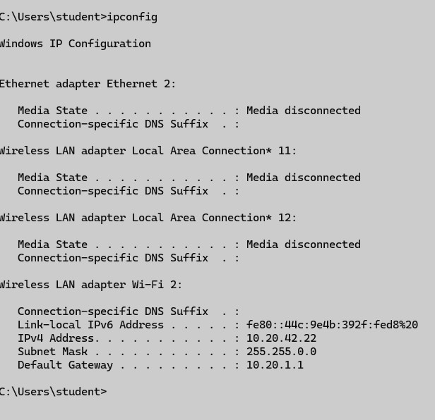

## 3)

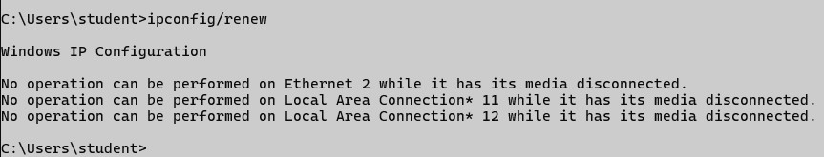

## 4)

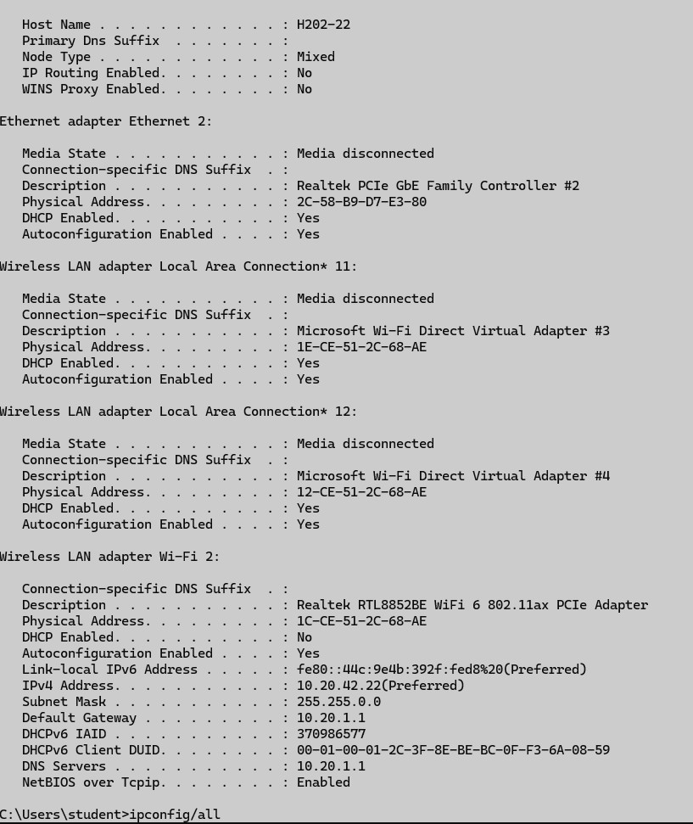

## 5)

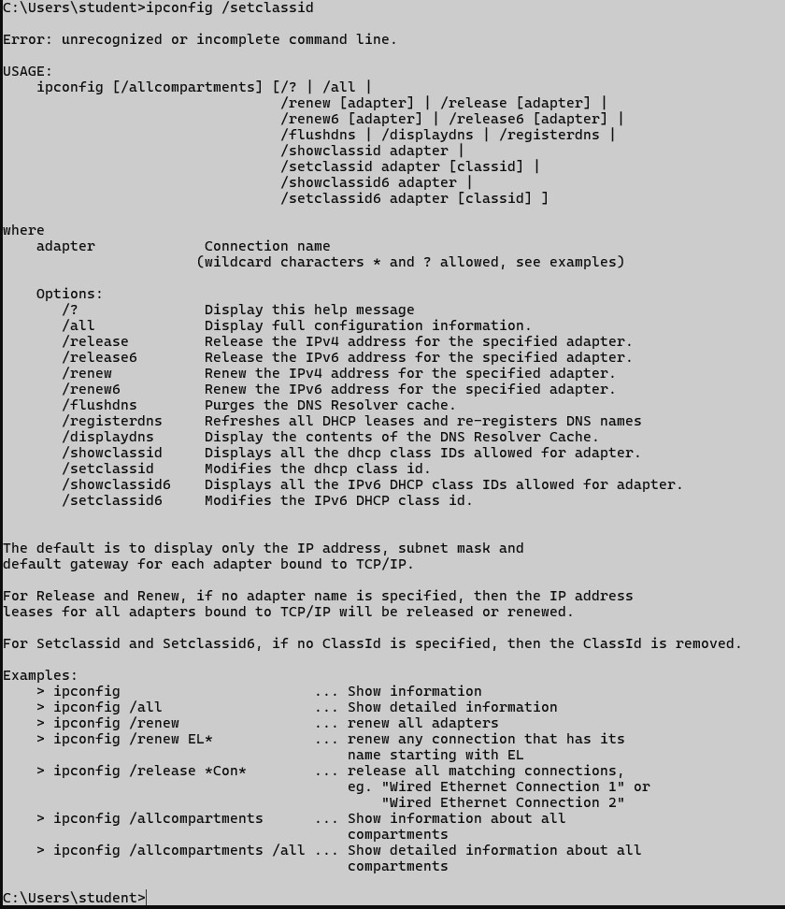

# 2. ping

**Description:**

|  |  |  |  |
| --- | --- | --- | --- |
| **No.** |  | **Option** | **Description** |
| **1** | Ping |  | Show your internet ping |
| **2** | -t |  | Ping the specified host until stopped. To see statistics and continue - type Control-Break; |
| **3** | /t |  | Specifies ping continue sending echo Request messages to the destination until interrupted. To interrupt and display statistics, press  CTRL+ENTER. To interrupt and quit this command, press CTRL+C. |
| **4** | /a |  | Specifies reverse name resolution be performed on the destination IP address. If this operation is successful, ping displays the corresponding host name |
| **5** | /n |  | Specifies the number of echo Request messages be sent. The default is 4. |

**Implementation:**

## 1)

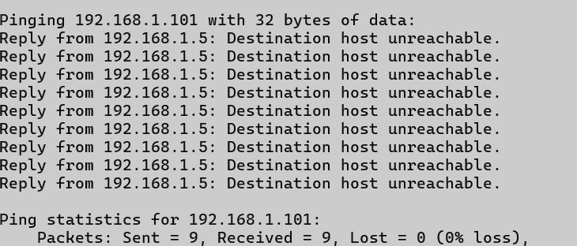

## 2)

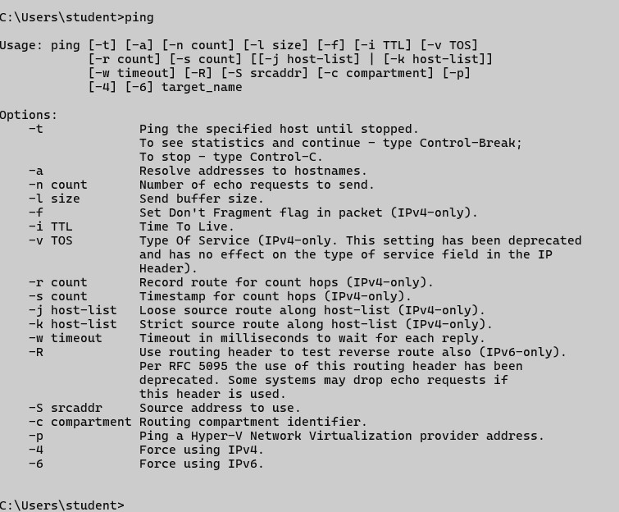

## 3)

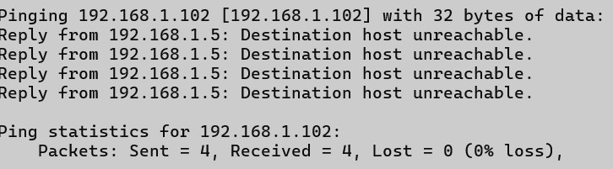

## 4)

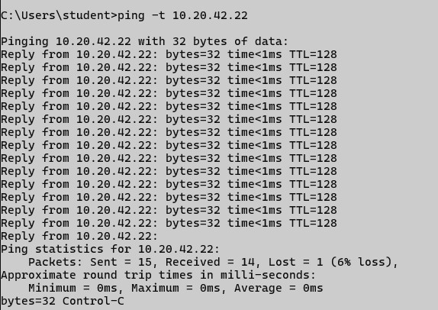

## 5)

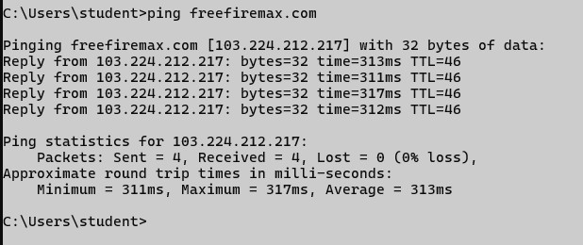

# 3. Getmac

**Description:**

|  |  |  |  |
| --- | --- | --- | --- |
| **No.** |  | **Option** | **Description** |
| **1** | Getmac |  | command is a Windows command-line utility used to display the Media Access Control (MAC)  address(es) of all network adapters on a local or remote computer |
| **2** | /v |  | Specifies that verbose output is displayed. |
| **3** | /s |  | Specifies the remote system to connect to. This can be an IP address or a hostname (do not use backslashes). The default is the local computer. |
| **4** | /nh |  | Specifies that the "Column Header" should not be displayed in the output. Valid only for TABLE and CSV formats |
| **5** | /? |  | Displays help at the command prompt |

## 1)

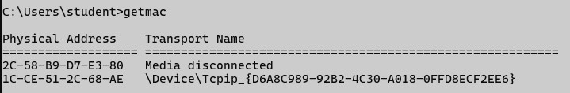

## 2)

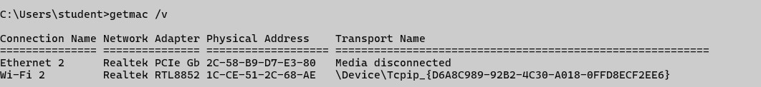

## 3)

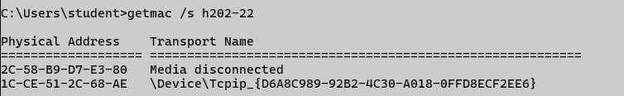

## 4)

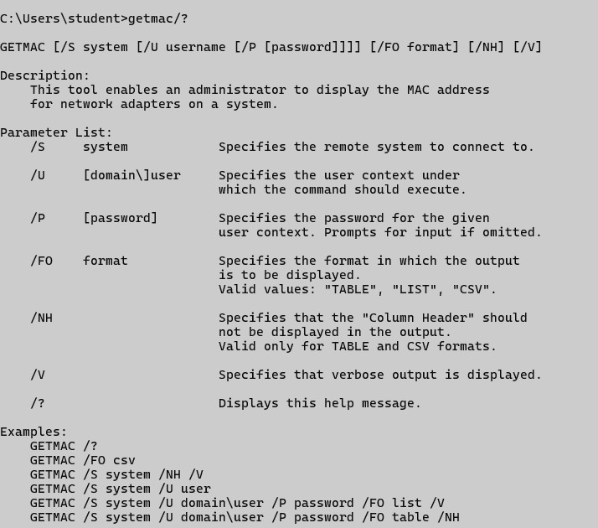

## 5)

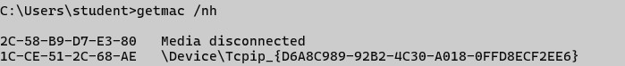

**4. SystemInfo Description:**

|  |  |  |  |
| --- | --- | --- | --- |
| No. |  | Option | Description |
| 1 | SystemInfo |  | systeminfo is a Windows command-line tool used  to display detailed information about a computer's system configuration, operating system, and network settings, helpful for diagnostics, inventory, and network administration. |
| 2 | /? |  | It shows the help manual for any command in the Command Prompt (CMD) |
| 3 | /fo |  | Specifies the output format. Options: TABLE, LIST, or CSV.. |
| 4 | /fo csv |  | Export System Info in CSV Format (for scripting or Excel) |
| 5 | /nh |  | "No Header" – Omits column headers in the output (works with /fo TABLE or /fo CSV) |

## 1)

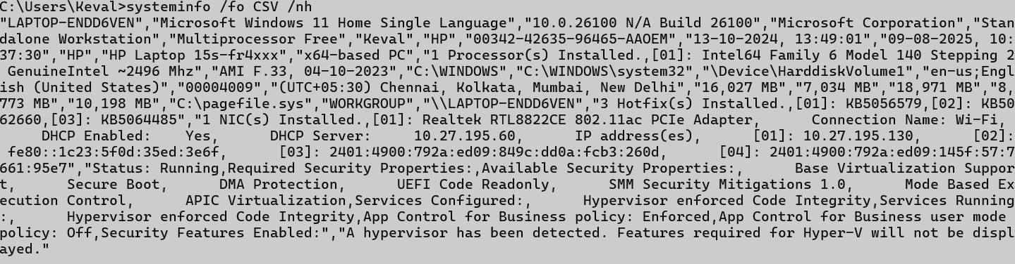

## 2)

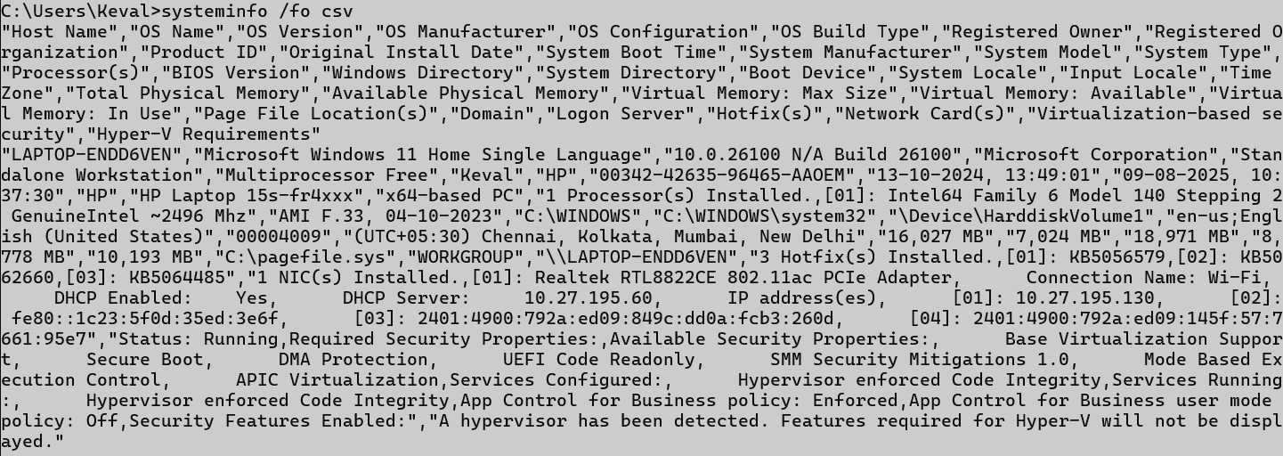

## 3)

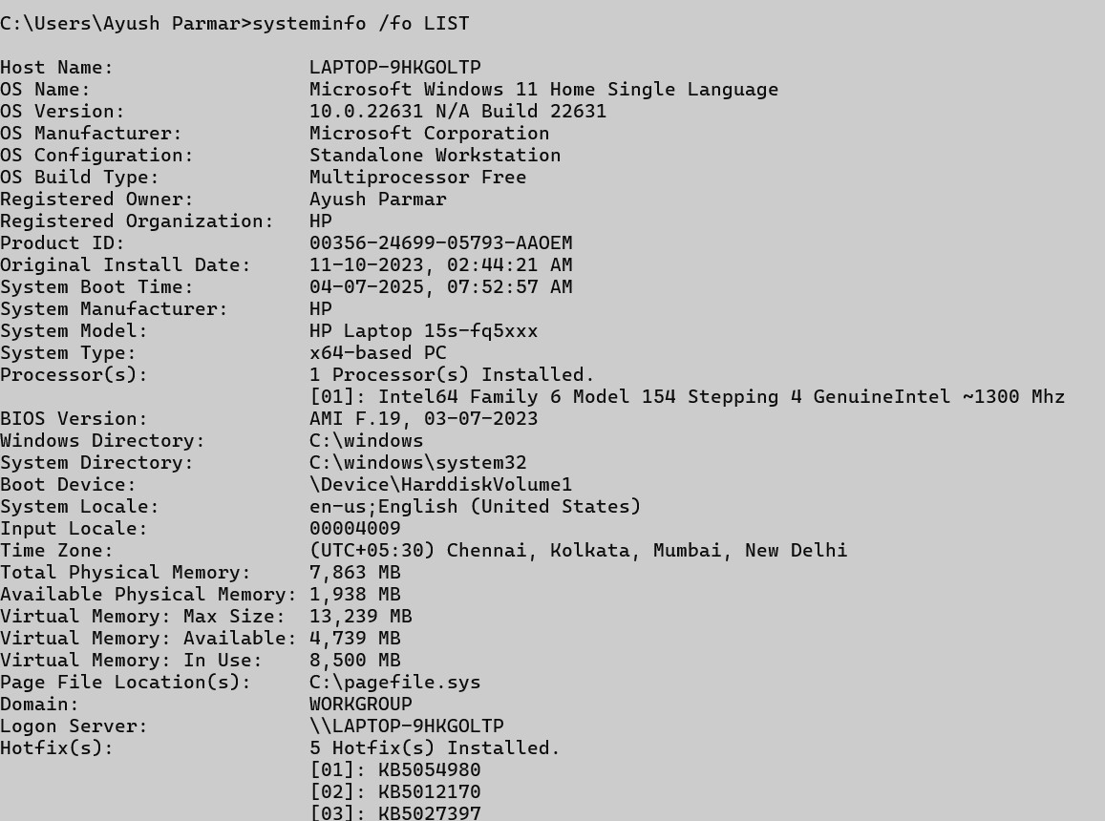

## 4)

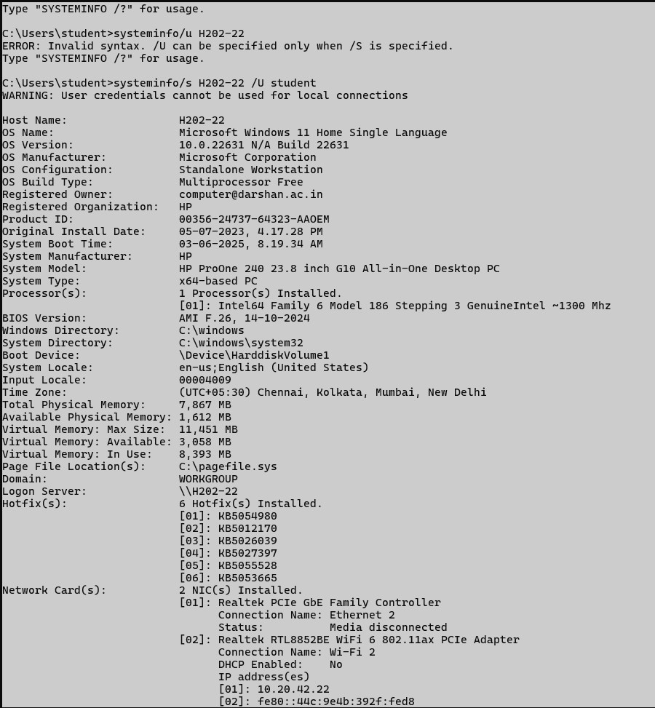

## 5)

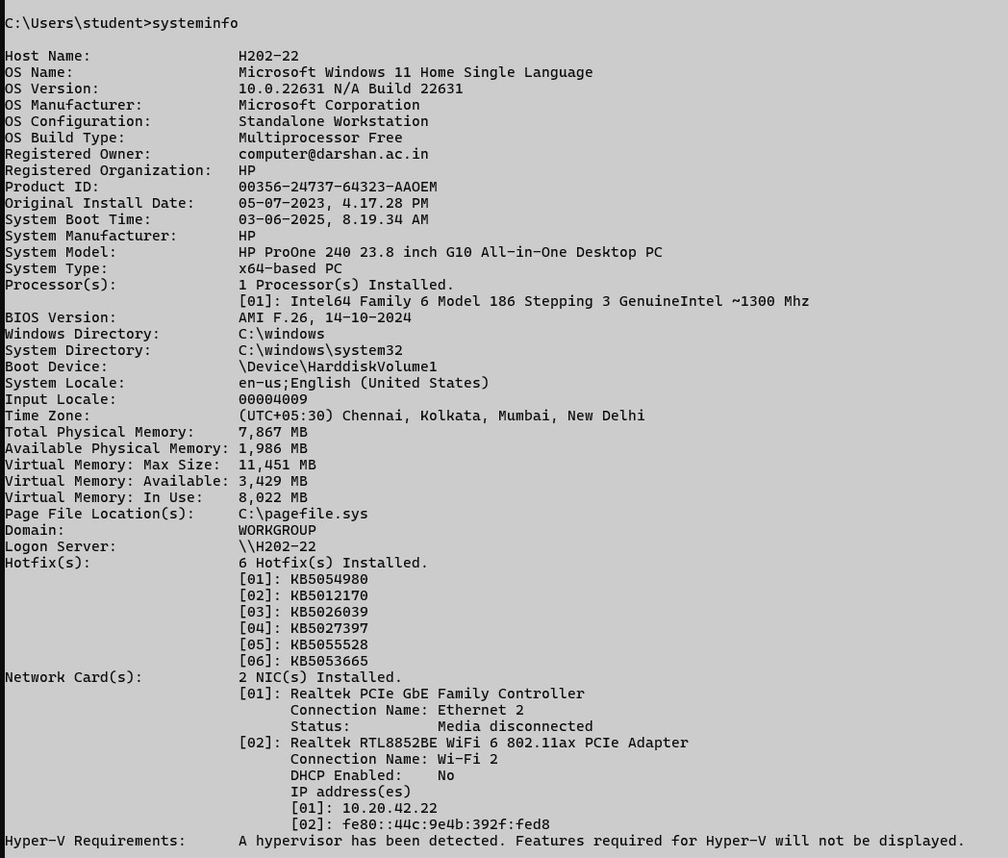

|  |  |  |
| --- | --- | --- |
| No. | Option | Description |

# 5. Tracert

**Description:**

|  |  |  |
| --- | --- | --- |
| 1 | tracert | tracert is a Windows command-line tool used to trace the route and measure the delay of packets from your computer to a destination host, helping diagnose network path or connectivity issues. |
| 2 | /d | Do not resolve hostnames (faster output by skipping DNS lookups). |
| 3 | /h | Set maximum number of hops |
| 4 | /w | Timeout in milliseconds to wait for each reply. |
| 5 | /4 | Forces IPv4 tracing |

## 1)

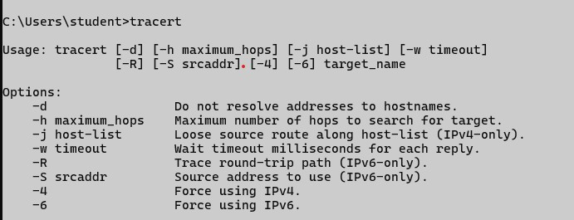

## 2)

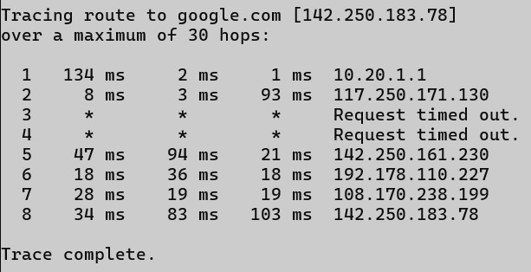

## 3)

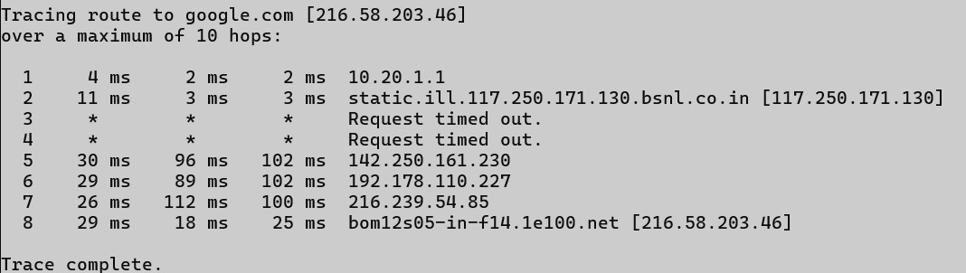

## 4)

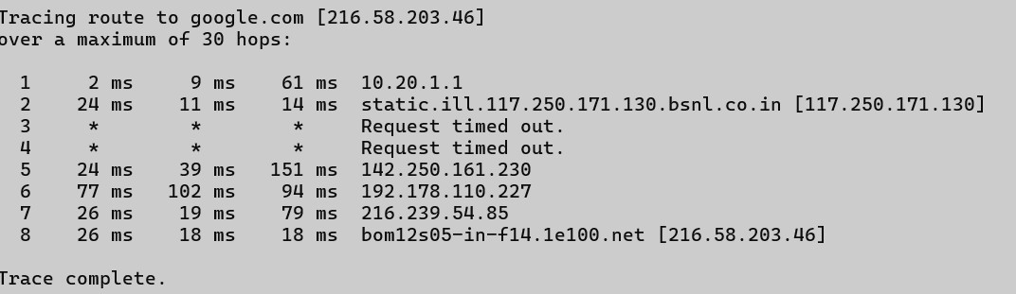

## 5)

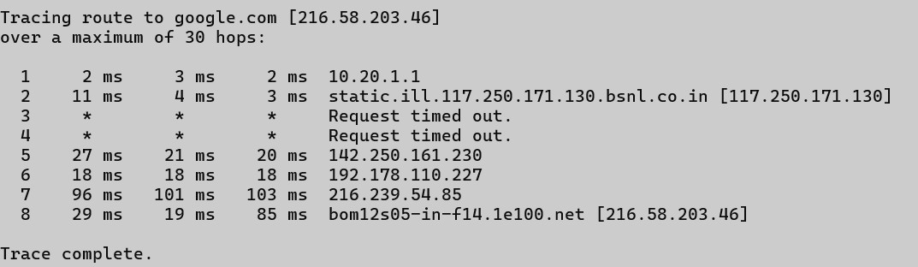

# 6. Netstat

**Description:**

|  |  |  |  |
| --- | --- | --- | --- |
| No. |  | Option | Description |
| 1 | netstat |  | is a command-line tool used to display active network connections, open ports, and routing |
|  |  | | tables, helping monitor and troubleshoot network-related issues |
| 2 | -a | | Shows all connections and listening ports |
| 3 | -n | | Shows IP addresses and port numbers without DNS names (faster) |
| 4 | - r | | Displays the routing table (same as route print). |
| 5 | - o | | Displays the owning process ID (PID) for each connection. |

## 1)

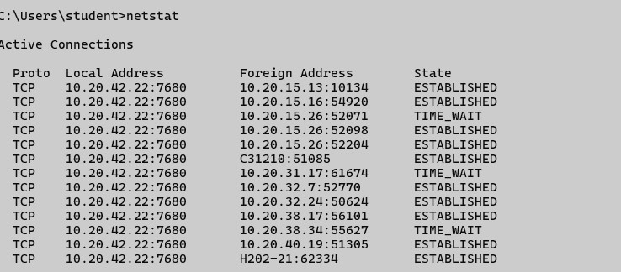

## 2)

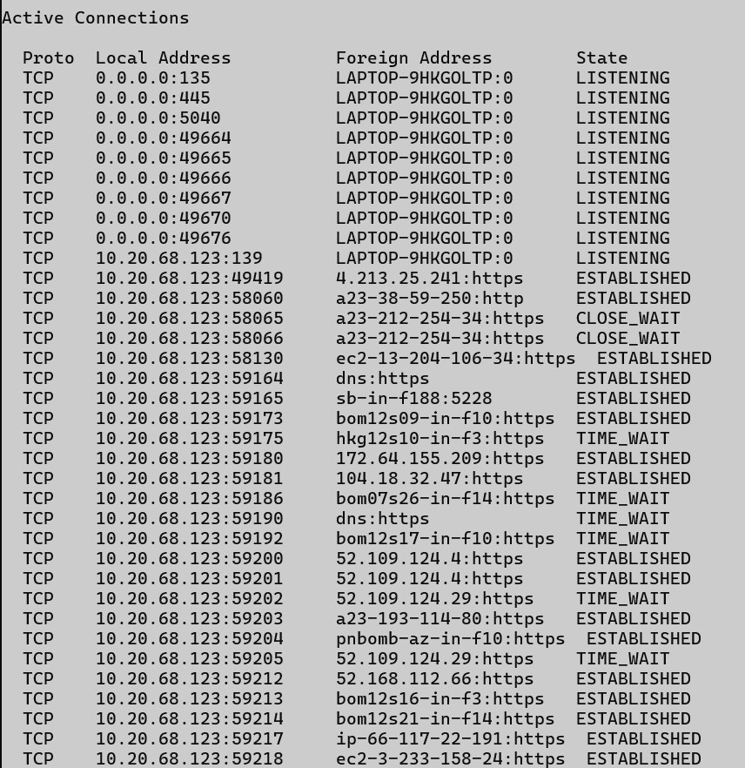

## 3)

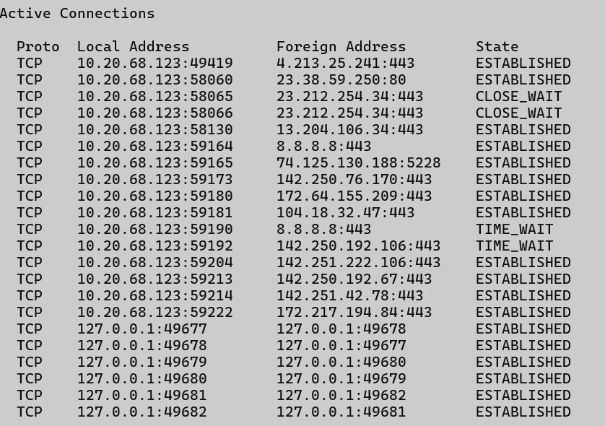

## 4)

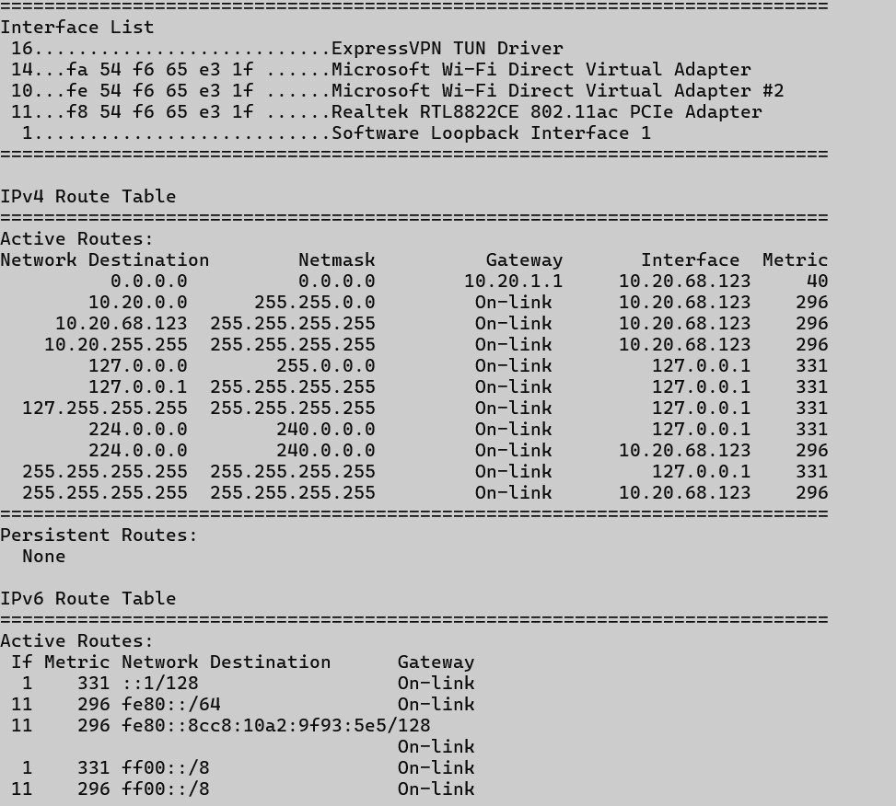

## 5)

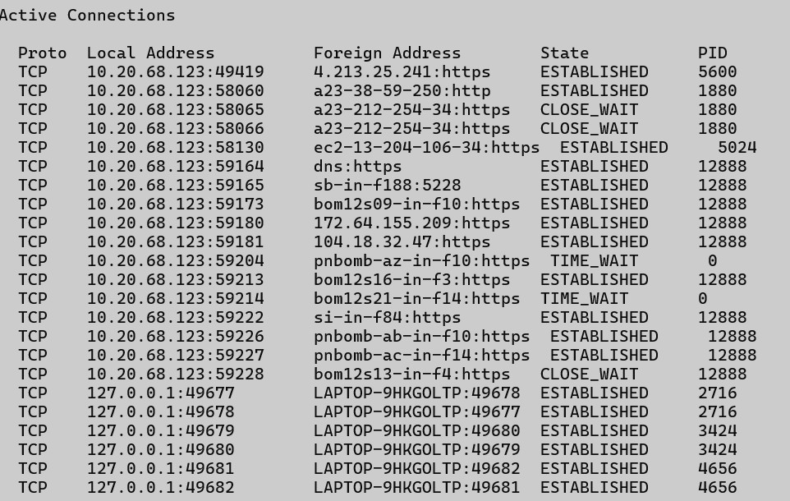

**7. Nslookup Description:**

|  |  |  |  |
| --- | --- | --- | --- |
| No. |  | Option | Description |
| 1 | Nslookup |  | is a command-line tool used to query DNS servers and retrieve information about domain names, IP addresses, mail servers, and more |
| 2 | -type=A |  | Lookup IPv4 address records (default). |
| 3 | -type=AAAA |  | Lookup IPv6 address records |
| 4 | -type=MX |  | Displays the routing table (same as route print). |
| 5 | 8.8.8.8 |  | Reverse IP lookup |

## 1)



## 2)

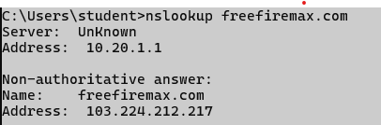

## 3)



## 4)



## 5)



# 8. Hostname

**Description:**

|  |  |  |  |
| --- | --- | --- | --- |
| No. |  | Option | Description |
| 1 | Hostname |  | The hostname command is used to display the name of the current computer (host) on a network. |

## 1)



**9. Pathping Description:**

|  |  |  |  |
| --- | --- | --- | --- |
| No. |  | Option | Description |
| 1 | Pathping |  | pathping is especially helpful for detecting where in a network path packet loss occurs.  Let me know if you want a comparison with ping and tracert or want results explained. |
| 2 | /n |  | Do not resolve IP addresses to hostnames (faster output) |
| 3 | /h |  | Limit the maximum number of hops (default is 30) |
| 4 | /g |  | Specify a list of gateways (routers) the packet must go through. |
| 5 | /p |  | Set the wait time (in milliseconds) between pings (default is 250ms). |

## 1)

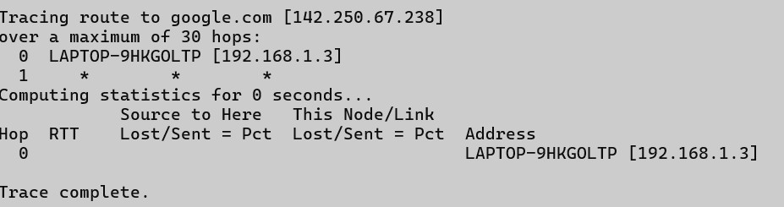

## 2)

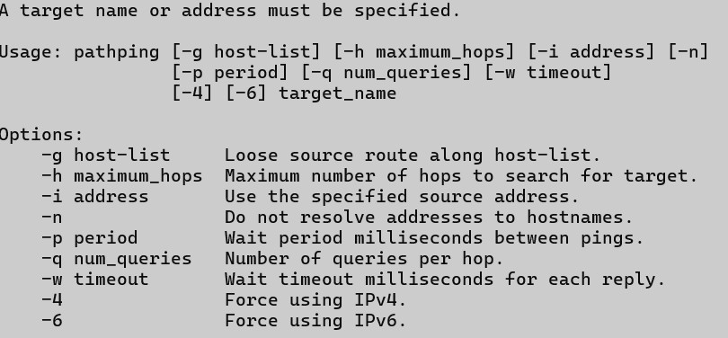

## 3)

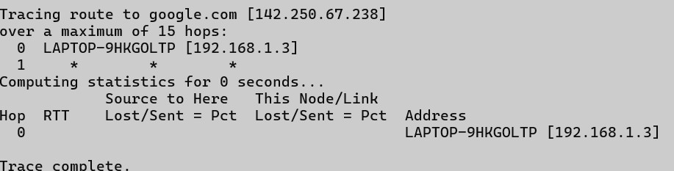

## 4)

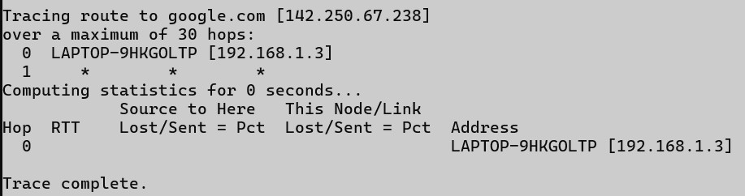

## 5)

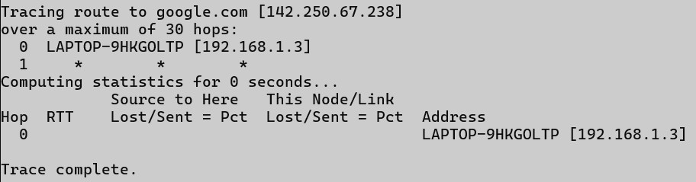

# 10. Arp

**Description:**

|  |  |  |  |
| --- | --- | --- | --- |
| No. |  | Option | Description |
| 1 | Arp |  | The arp command is used to view and manage the ARP (Address Resolution Protocol) cache on a computer. It helps map IP addresses to MAC (hardware) addresses, which is essential for network communication within a local subnet |
| 2 | -a |  | Display current ARP entries |
| 3 | -g |  | Same as -a |
| 4 | -v |  | Verbose mode – show more details |
| 5 | -d* |  | Delete all ARP entries |

## 1)

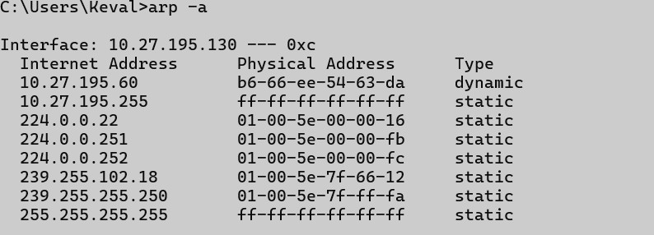

## 2)

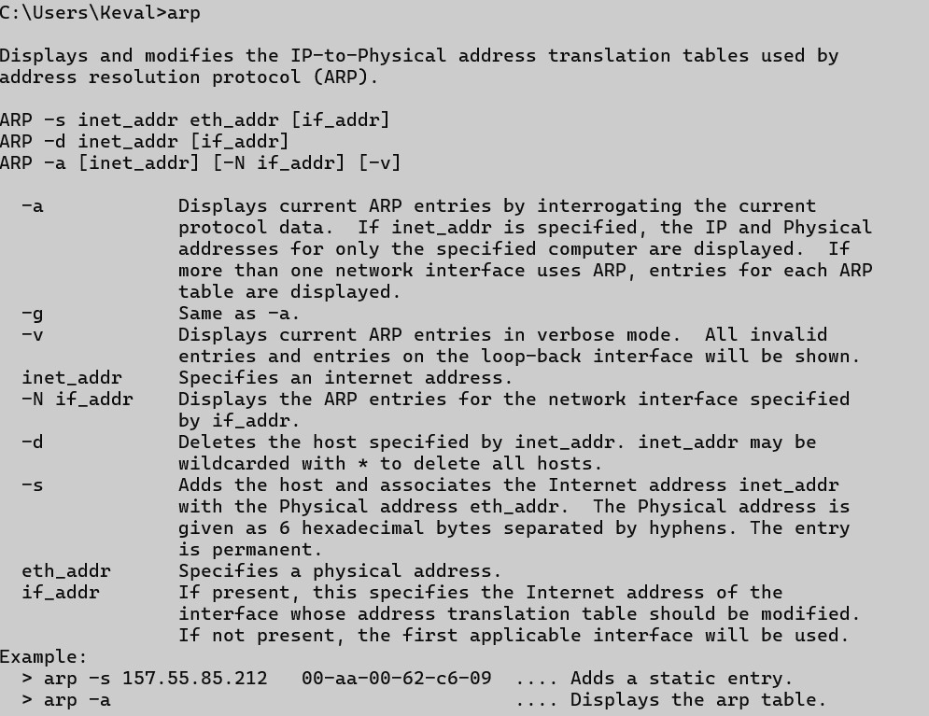

## 3)

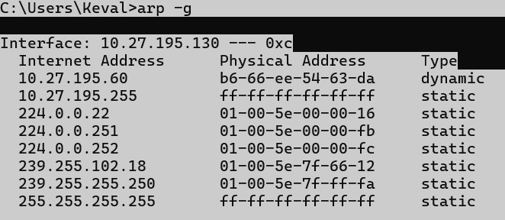

## 4)

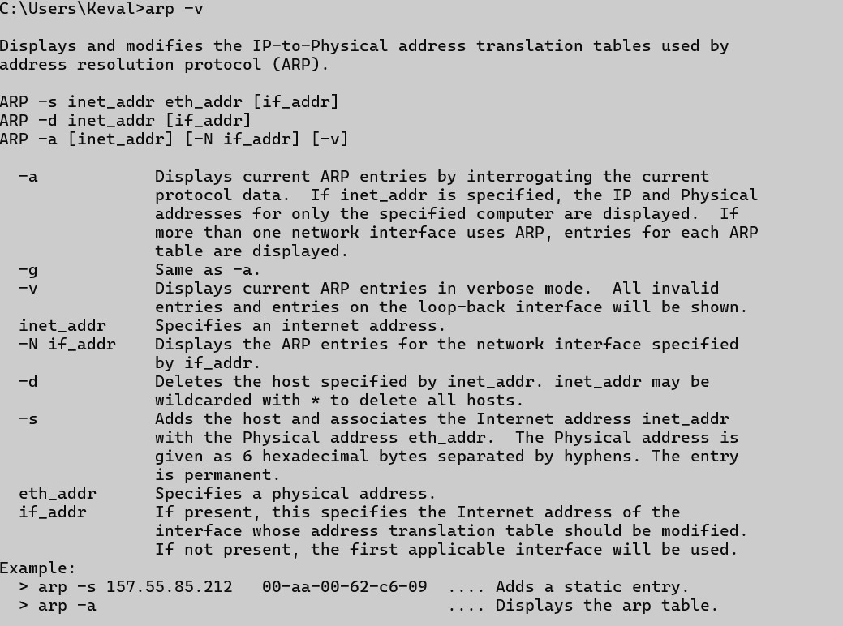

## 5)

